GBL Landing Page: Content updates

-------------------------------------------------------
A PARTICIPANT
The centre of the network
A participant
It takes an ecosystem to build a livelihood
Every participant’s journey is different. Some need skills to enter the labour market. Others need equipment, business support or access to customers. Many need help navigating personal, financial and structural barriers along the way.
Generating Better Livelihoods for Grant Recipients (GBL) brings together government, implementing partners, service providers, community organisations and economic opportunities around each participant’s needs and aspirations.
Explore the network to see how these connections work, with the participant at the centre.
Stories of change
Read participant journeys from across the programme.→
18–35 Age range
5,000 Participants in the GBL project
7 Sites across three provinces
Learn about the programme

-------------------------------------------------------
PARTICIPANT JOURNEY
Their coach and frontline support
Linkages Facilitators: Supporting each participant’s journey
Linkages Facilitators work directly with participants to understand their circumstances, identify barriers and build practical plans towards sustainable livelihoods.
Through four core functions – profiling, linking, supporting and sustaining – they help participants recognise their strengths and aspirations, access relevant services and economic opportunities, and receive ongoing guidance as they work towards their goals.
This coordinated, personalised support helps participants put their plans into action, build on their progress and strengthen their pathways to sustainable livelihoods.

1,855 Participants profiled

Meet the Linkages Facilitators

Nompumelelo Zulu
Mthwalume, KwaZulu-Natal
Nompumelelo has a strong enterprise and skills-development focus, helping participants move from business aspirations towards practical training, company registration and preparation to start their businesses.
mthwalume@finmark.org.za

Nelisiwe Blose
KwaMashu, KwaZulu-Natal
Nelisiwe provides practical, opportunity-focused coaching, helping participants prepare for employment while connecting aspiring entrepreneurs to funding, registration and skills-development support.
kwamashu@finmark.org.za

Nokuthula Ngcobo
KwaMashu, KwaZulu-Natal
Nokuthula brings a holistic, persistent approach to coaching, staying closely engaged with participants while helping them navigate livelihood opportunities and immediate social and household challenges.
kwamashu2@finmark.org.za

Philile Dube
Madadeni, KwaZulu-Natal
Philile uses adaptive, highly individualised support around each participant’s chosen pathway, drawing on community networks to overcome barriers as they arise.
madadeni@finmark.org.za
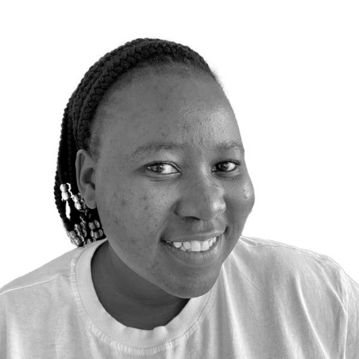
Zanele Mpungose
Madadeni, KwaZulu-Natal
Zanele is a Linkages Facilitator who empowers aspiring entrepreneurs through practical guidance, peer learning and business development support. She helps participants navigate funding opportunities, business registration and the essential steps to establishing sustainable businesses.
madadeni2@finmark.org.za
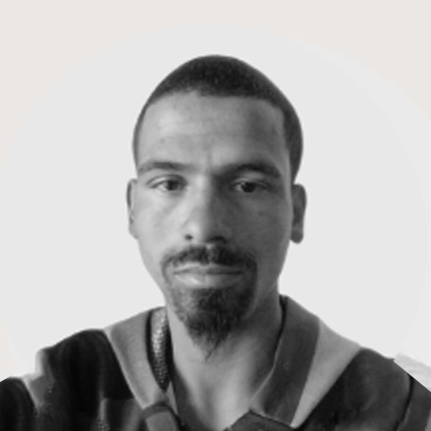
Shennin Cornellissen
Oppermansdorp, Free State
Shennin demonstrates a strong understanding of participants’ economic realities, recognising how household pressures, debt, education and limited local opportunities shape the livelihood choices people can make.
oppermans@finmark.org.za

Rethabile Sebakamotse
Virginia, Free State
Rethabile’s strength is keeping participants engaged and opportunity-ready through regular check-ins, group sessions and practical job-search support, despite limited long-term opportunities.
virginia@finmark.org.za
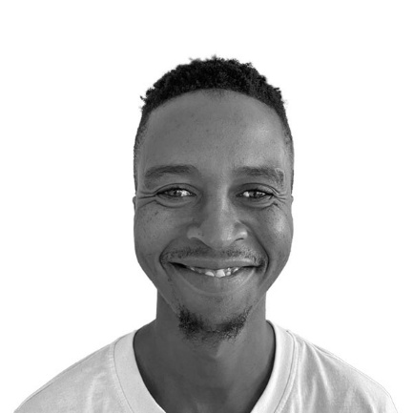
Thabiso Sekhejane
Meloding, Free State
Thabiso brings a realistic, critical eye to the barriers participants face, particularly where weak employment linkages and slow funding processes prevent progress. He works to align support programmes from all stakeholders with the graduation criteria, making graduation a well-planned, seamless journey.
meloding@finmark.org.za
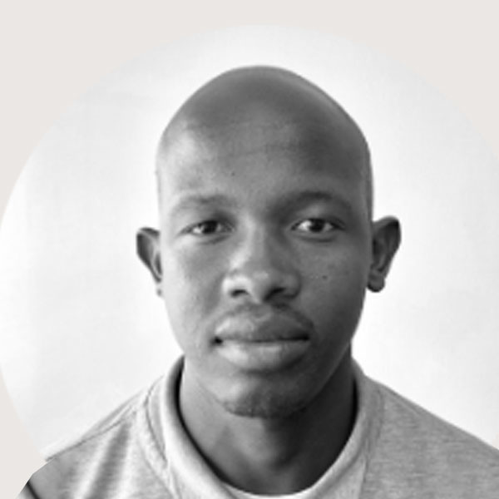
Xolile (Vusi) Stuurman
Sebokeng, Gauteng
Xolile brings a hands-on, problem-solving approach, providing participants with practical support ranging from applications and interview preparation to internet access and spaces for virtual interviews, virtual classes and work-from-home activities.
sebokeng@finmark.org.za
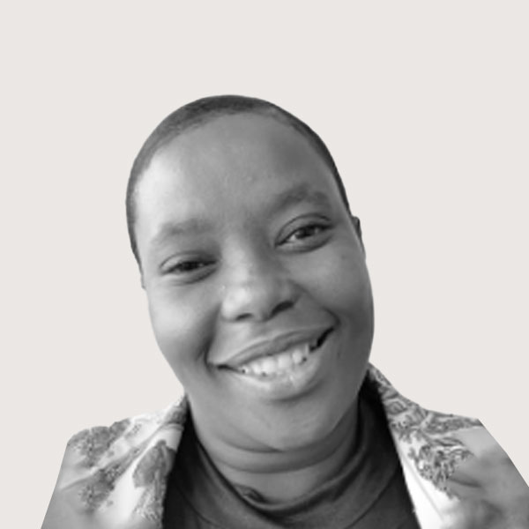
Seipati Mosebetsi
Randfontein, Gauteng
Seipati provides consistent, relationship-based support, staying in regular contact with participants and helping them adapt their livelihood plans when businesses or employment opportunities do not provide sufficient income.
randfontein@finmark.org.za

Coaching network
Community Development Practitioners (CDPs)
(PILLARS)
PARTICIPANT JOURNEY · PILLAR ONE  Social protection  Making sure participants receive the support to which they are entitled  The grant is the starting point, not the destination. The first pillar confirms that participants and their households receive everything they are entitled to and closes the gaps that stop people from claiming, missing documents, unregistered births, and unclaimed services.  The coach works with the local Department of Social Development office and SASSA outreach to resolve these issues, and refers participants to social work support where a household needs it. | PARTICIPANT JOURNEY · PILLAR TWO  Financial inclusion  Saving consistently and gaining access to finance participants can use  A financial buffer under a participant’s control changes what they can risk. The second pillar builds a regular saving habit, connects participants to appropriate formal financial products, and supports them through funding applications.  It also tracks what participants are moving away from – reliance on informal credit is one of the clearest signals that a household is becoming more resilient.
PARTICIPANT JOURNEY · PILLAR THREE  Social empowerment  Confidence, personal mastery and standing in the community  Personal mastery and social empowerment sessions build the confidence to act – to apply, to negotiate, to lead. This is usually where change becomes visible first, well before it shows up in income.  The coach delivers the sessions directly, allowing the pace to be adapted to the group’s needs and progress.  934 Completed personal mastery | PARTICIPANT JOURNEY · PILLAR FOUR  Livelihood promotion  Skills, productive assets, markets and work  Technical and business training, productive asset transfers, market links and placement into employment. Whether a participant is heading for a job or building an enterprise, this pillar makes the route concrete.  Participants are encouraged to build more than one income stream rather than betting everything on a single pathway, especially when farming is seasonal or an enterprise is still finding its feet.

Skills, enterprise and livelihood activity

586 Technical skills training
485 Business development training
28 training and livelihood moments from across the programme sites, including practical skills, enterprise support, work opportunities and completion milestones.

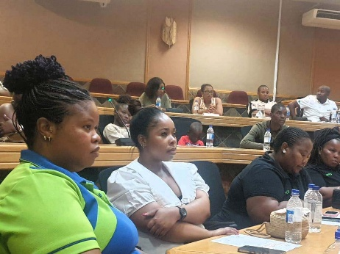
Enterprise support handover Participants at the Department of Social Development-led Amajuba Local Municipality handover.
Hlengokuhle Cakes With support from the NYDA, Hlengiwe Makhanya invested in bakery equipment.
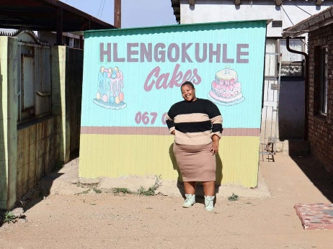
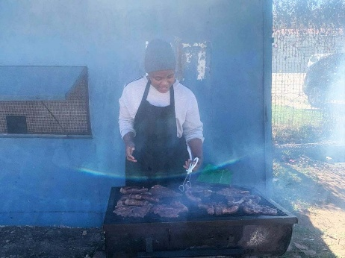
Food preparation and catering Practical food preparation training.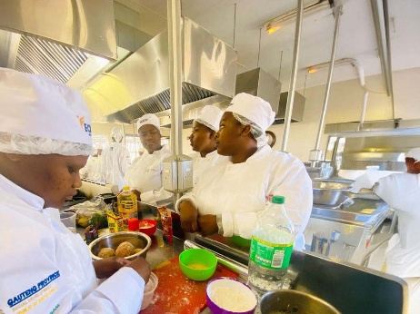

Hospitality training Bambisandlasam hospitality students take part in practical training.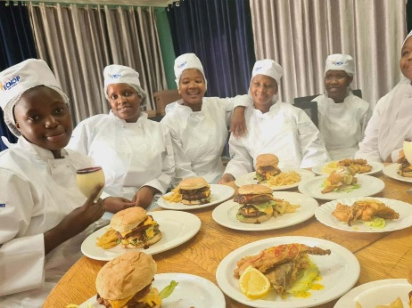
Hospitality training Students present dishes prepared during their practical training.
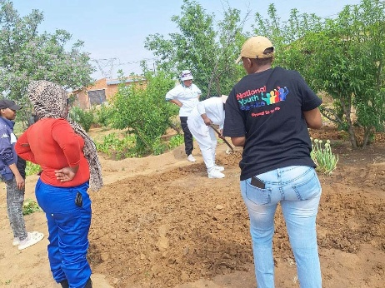
Agricultural training Participants learn essential agricultural skills.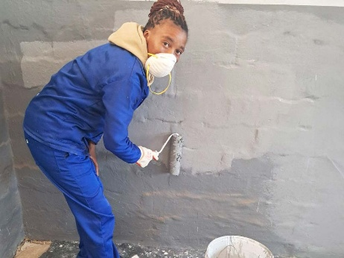
Painting skills Practical training equips participants with painting skills.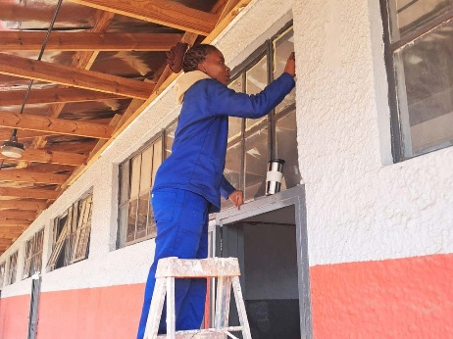
Part-time employment Participants put their painting skills to work in part-time jobs.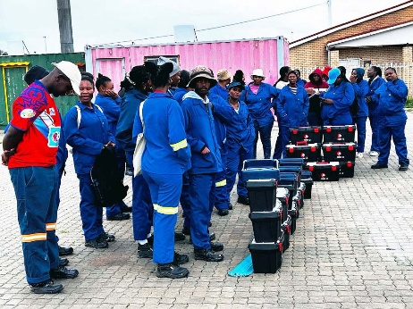
Toolbox handover Participants receive toolboxes to support their work.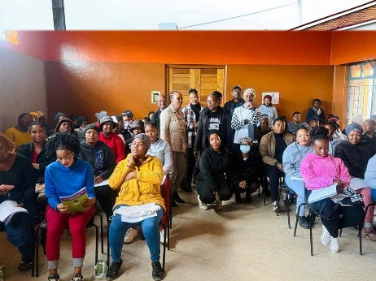
Financial literacy Participants take part in financial literacy training.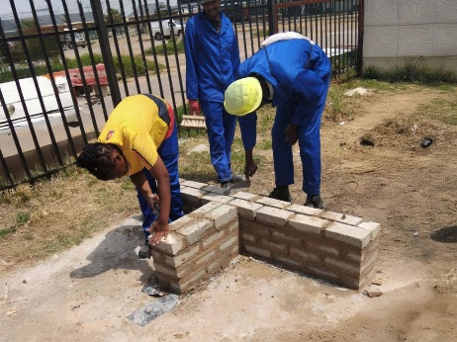
Bricklaying training Participants build practical bricklaying skills.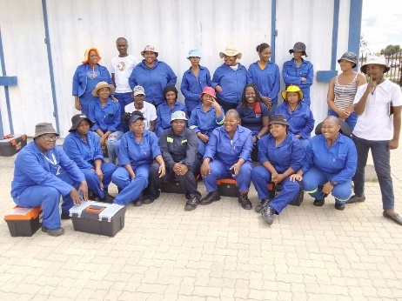
Bricklaying training A group of participants complete their practical training.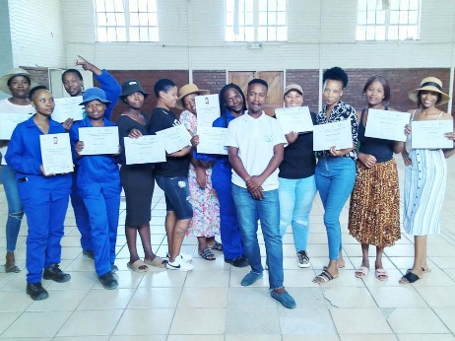
Generate Your Business Idea Participants complete the NYDA business idea training.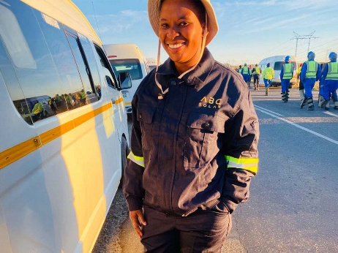
Solar project A participant linked to a solar project in Meloding.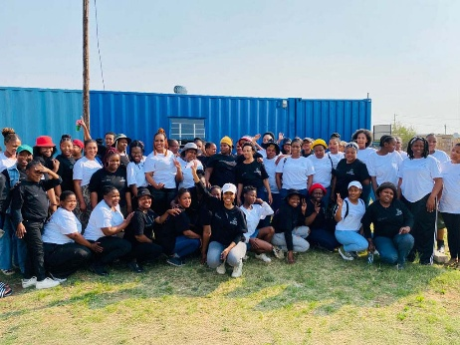
Active learning workshop Participants attend a five-day workshop hosted by the Seriti Institute for the NYS programme.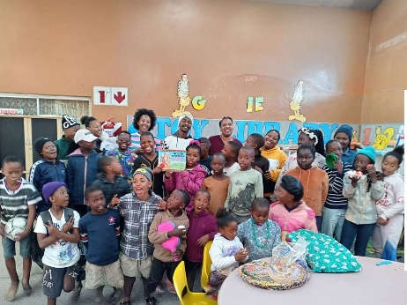
Giving back to the community Participants and children celebrate Mandela Day together.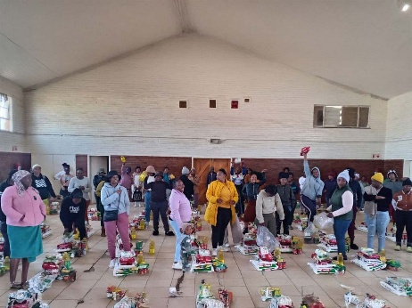
Household support Food parcels are prepared for distribution.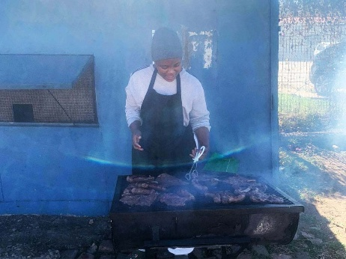
Fast-food enterprise A participant develops practical experience for a takeaway business.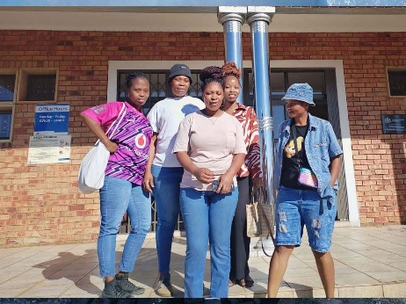
Entrepreneurial training Participants take part in SEDFA entrepreneurial training.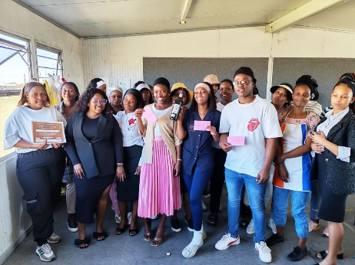
Business summit Participants showcase their ideas and pitch for cash prizes in Madadeni.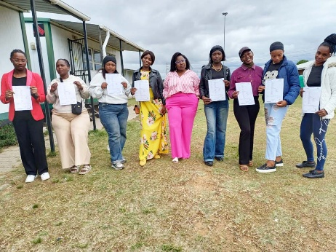
Business registration Business training and SEDFA support participants through the CIPC registration process.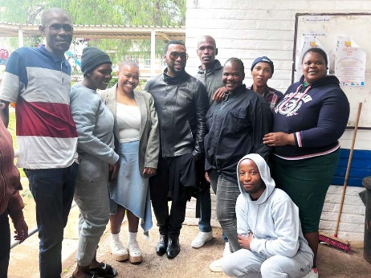
Garment construction David Tlale visits garment construction students at the Skills Centre to motivate them.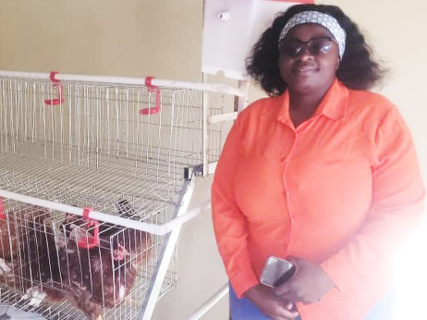
Poultry farming NYDA funding helps a participant establish an egg-producing small business.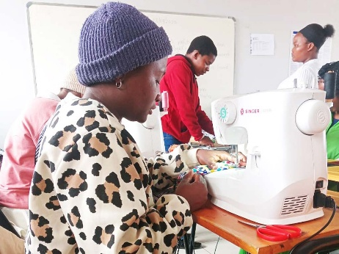
Community education and training A participant practises sewing at the Community Education and Training Skills Centre.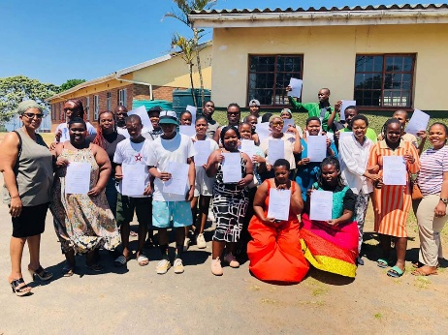
Training completion Participants celebrate receiving their certificates.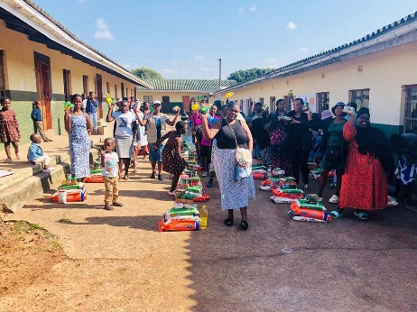
Household support Food parcels are distributed at a programme site.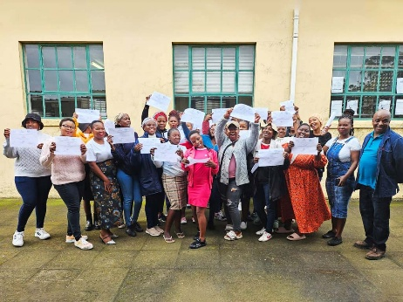
Business management Participants collect certificates for an NYDA business management course at the local SASSA office.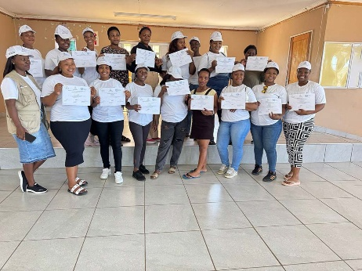
Start Your Own Business Participants complete the NYDA five-day Start Your Own Business training.

-------------------------------------------------------

PARTICIPANT SUPPORT NETWORK
Department of Social Development
Government principal, leading the programme

The National Department of Social Development leads the programme in partnership with its agencies, helping embed the GBL approach within government systems and support its long-term sustainability through public resources.
At local level, DSD offices and Community Development Practitioners help connect participants to relevant social services. Their involvement is important to extending the approach and supporting its integration into existing service delivery structures.

Visit partner websitewww.dsd.gov.za/Visit the DSD website

South African Social Security Agency
Administers social grants and identifies participants

SASSA administers South Africa’s social grants and helps identify grant recipients the programme can work with. Its community outreach also helps participants access services they could not reach on their own.
Visit partner websitewww.sassa.gov.za/
National Development Agency
Agency partner supporting delivery

The National Development Agency supports training, enterprise development and delivery at site level as one of the programme’s agency partners.
Visit partner websitewww.nda.org.za/
BRAC International
The Graduation approach and technical support

BRAC International provides technical support to the programme and brings the Graduation approach that GBL adapts to the South African context. This includes programme design, monitoring and learning support.
The approach combines four things at once – coaching, social empowerment, livelihood promotion and financial inclusion. By integrating these four components systematically, the approach helps participants make more sustainable progress towards improved livelihoods.
Visit partner websitewww.bracinternational.org/
FinMark Trust
Implements the project and connects delivery to evidence and policy

FinMark Trust implements the project, coordinates delivery across sites, supports the Linkages Facilitators and manages the programme’s implementation and learning systems.
Evidence from participant progress and implementation experience informs policy conversations about livelihood-focused social protection.
Visit partner websitefinmark.org.za/

Implementation partners
Partners translating livelihood plans into tangible opportunities

GBL works with a growing network of national and local partners who contribute practical support across the sites. Their support includes skills development, employment pathways, enterprise assistance, productive assets, funding, market access and community-based services.
Contributing partners include the National Youth Development Agency, Harambee Youth Employment Accelerator, HOPE Worldwide South Africa, and the National Home Builders Registration Council, along with other national, provincial, and community-based organisations.
Prospective partners are invited to connect with our National Business Development Manager to explore opportunities to support employment placements, skills training, enterprise development, funding, productive assets, market access or technical expertise.
Partnership contact
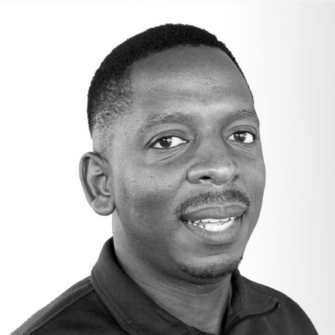
Matsiedi Malebatso
National Business Development Manager
matsiedim@sassa.gov.za

Training providers and employers
Where a qualification or a placement comes from

TVET and SETA colleges, accredited training providers, employers and recruitment agencies help turn aspirations into tangible opportunities, whether through certification, workplace experience, employment placements or first contracts.
Effective partnerships begin with understanding participants’ goals and pathways. Coaching builds that understanding, making participant support the foundation for meaningful partnerships.

Local government and community
Municipalities, ward councillors, traditional leaders and local organisations

Access to a community runs through its own structures. Ward councillors, municipal departments, traditional leaders, NGOs, and faith-based organisations help create local delivery pathways by providing venues, facilitating land-use rights for enterprises, and holding the programme locally accountable.
Linkages Facilitators maintain these relationships directly, allowing support to remain responsive to local needs while building trust within communities. This localised approach is a key strength of the programme and relies on continuous relationship-building.

Learning partners
University of Johannesburg and SALDRU at the University of Cape Town

Independent research and learning partners help GBL understand what works, where barriers persist, and what is required to strengthen livelihood-focused social protection in South Africa.
By combining participant experiences, frontline insights and implementation evidence, they generate practical knowledge that informs better support, stronger institutional coordination and opportunities for wider adoption.

Learning publications
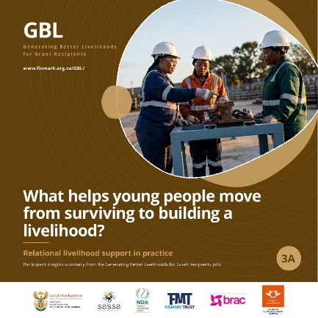
Learning Brief 3A
What helps young people move from surviving to building a livelihood?
Relational livelihood support in practice: participant insights from the Generating Better Livelihoods for Grant Recipients project.
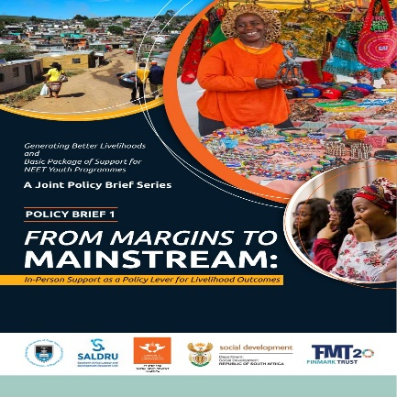
Joint Policy Brief 1
From Margins to Mainstream: In-Person Support as a Policy Lever for Livelihood Outcomes
Part of the Generating Better Livelihoods and Basic Package of Support for NEET Youth Programmes joint policy brief series.

Management information system (MIS)
Where coaches record and track each participant’s progress over time

The management information system (MIS) provides a central platform for coaches to record participant profiles, development plans, referrals, training, services and livelihood milestones across the four pillars. It enables coaches to track progress over time, identify outstanding support needs and follow up with participants as required.
By creating a consistent record across all sites, the MIS also helps the programme monitor participant progress and assess movement towards graduation and more sustainable livelihoods.

4 Pillars tracked
Ongoing Progress record
Service provider enquiries
Training providers, employers and other livelihood partners are invited to share opportunities, services and their eligibility requirements with the programme. Using participant profiles and progress information, Linkages Facilitators can identify suitable candidates and support the referral process.
When contacting the team, please include the opportunity type, location, dates, number of available places and eligibility or selection criteria.
info@finmark.org.za+27 (0) 67 594 9291

-------------------------------------------------------
ABOUT THE PROGRAMME
About the programme
The challenge
Why coordinated support matters

Social grants provide an essential safety net for millions of South Africans. But for many recipients, access to skills, employment, enterprise opportunities and sustained support remains limited.
Training alone may not lead to employment. Business development support may have limited impact without equipment, markets or working capital. Participants facing personal or household challenges may need sustained support before they can take advantage of economic opportunities.
GBL is testing how social protection, personalised coaching, skills development, financial inclusion and livelihood opportunities can work together, with the participant at the centre.
Read the full picture

The Graduation approach
How GBL works
A pathway to opportunity

GBL adapts the internationally established Graduation approach to South Africa’s social protection and economic environment.
The approach combines social protection, livelihood promotion, social empowerment and financial inclusion. Rather than offering isolated interventions, it provides coordinated support based on participants’ individual circumstances, capabilities and goals.
A central feature is the role of Linkages Facilitators, who work directly with participants to identify barriers, develop practical plans and connect them to services and economic opportunities.
The four core coaching functions:
01 Profiling – Understanding each participant’s circumstances, strengths, needs and aspirations.
02 Linking – Connecting participants to training, services, funding and livelihood opportunities.
03 Supporting – Providing ongoing guidance, encouragement and practical assistance.
04 Sustaining – Helping participants strengthen their progress and resilience over time.
Livelihood pathways
01
Employment pathway
Participants are supported to identify suitable employment opportunities, build their job readiness, access relevant skills development and connect with employers or placement partners. Linkages Facilitators help participants overcome barriers, navigate opportunities and sustain progress as they transition into work.
02
Entrepreneurship pathway
Participants with entrepreneurial ambitions receive tailored support to strengthen their business skills, access productive assets and funding, build market links and grow sustainable enterprises. Linkages Facilitators provide ongoing guidance to help participants turn business ideas into viable sources of income and long-term livelihood opportunities.
View and fund a participant-run MSME→
Explore the four pillars
01Social protection
02Financial inclusion
03Social empowerment
04Livelihood promotion

The GBL Graduation Process
The complete participant pathway, from mobilisation and profiling to personalised support, livelihood development, and progression toward sustainable livelihood outcomes.
Open the full-size process ↗
Programme brochure
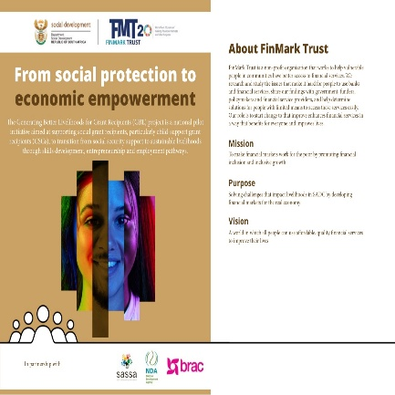
GBL programme brochure
From social protection to economic empowerment
An overview of the programme, its partnerships, the Graduation approach, participant pathway and delivery model.
See the pillars and the pathway

About the programme
Our impact so far
Progress in building livelihood pathways

Across the project, participants access personalised support, develop new skills, and progress along employment and entrepreneurship pathways.
These figures provide a snapshot of participant reach and support recorded through the programme’s management information system. Training categories may overlap.
1,855 Participants profiled
232 Linked to employment pathways
320 Operating businesses
26 NYDA asset vouchers
934 Receiving personal mastery support
586 Receiving technical skills training
782 Receiving business development support
See the full tracker

About the programme
Stories of change
Participants’ journeys and coaches’ reflections

Behind every number is a person building a livelihood. GBL’s progress is best understood through the experiences of programme participants.
Across the sites, participants are developing skills, starting and strengthening businesses, accessing employment opportunities and building confidence in their ability to improve their circumstances.
These stories document the opportunities, challenges and support that shape their journeys.
Participant impact stories
21 participant journeys showing progress through employment, enterprise, education, productive assets and combined livelihood pathways.
Province All provinces | Free State | Gauteng | KwaZulu-Natal
Livelihood pathway All pathways | Employment | Entrepreneurship
Type of support All support types | Personal development and wellbeing | Employment preparation and placement | Business development | Financial capability | Funding and productive assets | Technical and vocational skills | Coaching and mentorship | Clear filters
Showing all 21 stories
01Amanda Novukela
From vulnerability to economic agency+
Supported by Nokuthula Ngcobo · KwaMashu, KwaZulu-Natal
Employment | Entrepreneurship | Personal development and wellbeing | Business development | Financial capability | Funding and productive assets | Coaching and mentorship
When Amanda joined GBL in September 2024, she was unemployed and living with her mother, daughter and four siblings in a single-room home. Her household relied heavily on social grants, while alcohol dependency and financial pressure left her feeling lost and uncertain about how to change her circumstances.
Amanda committed fully to the programme. Life-skills and mindset-shift sessions helped her rebuild confidence, while ongoing coaching with Linkages Facilitator Nokuthula Ngcobo strengthened her personal mastery, financial discipline and decision-making. She also completed financial literacy and business management training.
She has since secured a one-year position with the Community Safety and Liaison Department, earning a reliable monthly income. Alongside employment, she runs Dynamite Day Care Centre for 13 children, sells eggs and spices, and maintains a vegetable garden with her mother.
By combining employment with several enterprise activities, Amanda has created a more resilient livelihood. She saves regularly, is increasing her productive assets and is using her income to build a four-room family home. Her next step is to seek NYDA funding to expand her businesses while continuing light-touch mentorship.
“Today, I am an employee at the Community Safety and Liaison Department earning my own salary, a day care owner, a business owner selling spices and eggs, and a homeowner. I can finally give my daughter and my family a proper future.”
02 Snethemba Hope Hadebe
Restoring hope and rebuilding opportunity+
Supported by Nokuthula Ngcobo · KwaMashu, KwaZulu-Natal
Employment | Personal development and wellbeing | Business development | Financial capability | Coaching and mentorship
A serious motor vehicle accident in 2021 left Snethemba with a physical disability affecting the right side of her body. By the time she joined GBL in November 2024, she was unemployed, supporting herself and her son mainly through a social grant, and had lost confidence in her prospects of returning to university or becoming financially independent.
Working with Linkages Facilitator Nokuthula Ngcobo, Snethemba developed an Individual Development Plan centred on her challenges and aspirations. Personal mastery, life skills, business management and financial literacy training were combined with sustained coaching, mentoring and psychosocial support.
Snethemba has since secured permanent full-time employment at Woolworths and returned to her Bachelor of Education studies through UNISA. She saves regularly, maintains financial records, uses credit responsibly and is planning a safer home for herself and her son.
Now nearing graduation from GBL, Snethemba is consolidating her financial progress while continuing her studies. Her journey shows how rebuilding confidence and capability can open a path towards income, education and greater independence.
“The programme helped me regain hope and confidence. Today I have a full-time job, I can provide for my son, and I am planning for a better future. GBL showed me that my disability does not define my future.”
03 Nomthandazo Dlamini
Returning to a hospitality career path+
Supported by Nelisiwe Blose · KwaMashu, KwaZulu-Natal
Employment | Personal development and wellbeing | Employment preparation and placement | Business development | Technical and vocational skills | Coaching and mentorship
Nomthandazo held an N6 qualification in Hospitality and Catering but had become discouraged after repeated unsuccessful attempts to secure in-service training. Through mindset and business management training, one-on-one coaching and Harambee job-readiness support, she regained confidence and resumed applying.
She subsequently secured an 18-month in-service placement at Coastlands Hotel. The placement helps her meet household needs and save towards building her own home, while restoring her confidence and career direction.
“GBL helped me regain confidence, hope and, with so much support from the LF and other participants, I felt seen and heard.”
04 Thabile Wendy Dladla
Formalising and growing a floor-paint business+
Supported by Nelisiwe Blose · KwaMashu, KwaZulu-Natal
Entrepreneurship | Personal development and wellbeing | Business development | Financial capability | Coaching and mentorship
Thabile entered GBL with a small floor-paint manufacturing business, few customers and limited knowledge of marketing or business management. Coaching, business management and mindset training, social-media marketing guidance and financial literacy helped her establish stronger foundations.
Her business is now registered, she sources raw materials directly and has expanded her customer base. Savings through a community stokvel enabled her to buy a vehicle for transporting chemicals and delivering products. Her next ambition is to expand into wall and tile paint.
“Today my business is registered, I have many more customers, I save regularly through my community stokvel, and I am confident about growing my business even further.”
05 Thobekile Ndlovu
Restoring confidence to re-enter work+
Supported by Nelisiwe Blose · KwaMashu, KwaZulu-Natal
Employment | Personal development and wellbeing | Employment preparation and placement | Coaching and mentorship
Thobekile had stopped applying for jobs after a long period of discouragement and unemployment. Through life-skills training, Harambee job-preparedness support and regular coaching, she updated her CV, began applying again and rebuilt her confidence.
She secured a casual sales position at Garment Division. The income helps cover food and her child’s education, while the participant record also points to increased resilience and a renewed sense of possibility.
“The support and motivation that I receive from you (LF) is incredible. It pushes me to focus on achieving my hopes and dreams.”
06 Nelisiwe Dube
Building Nzawukele Hair Salon+
Supported by Zanele Mpungose · Madadeni, KwaZulu-Natal
Entrepreneurship | Personal development and wellbeing | Business development | Financial capability | Funding and productive assets | Coaching and mentorship
Nelisiwe had developed hair-braiding skills, but her business remained informal and lacked the systems needed for growth. Through GBL she received personal mastery coaching, life-skills support, entrepreneurship and business management training, financial literacy, and help with registration and record-keeping.
She registered Nzawukele Hair Salon, introduced invoicing and financial records and improved cash management. She also received R10,000 in business funding. The salon has expanded and now employs two people.
“Meeting Zanele Mpungose and joining the GBL project changed my life.”
07 Nondumiso Happiness Lushaba
Turning personal responsibility into enterprise leadership+
Supported by Zanele Mpungose · Madadeni, KwaZulu-Natal
Entrepreneurship | Business development | Financial capability | Coaching and mentorship
After the loss of her mother, Nondumiso carried significant family responsibilities while building income through small activities. Through GBL she received profiling, coaching, mentorship, entrepreneurship and financial literacy support, together with support from SEDA and NYDA.
She has established and diversified a beauty salon, improved her financial management, facilitated entrepreneurship workshops and created business space for two women. Her journey reflects a shift from earning for survival towards creating opportunities for others.
“Through the guidance of my mentor, Zanele Mpungose, and the opportunities provided through GBL, I have grown not only my business but also my confidence.”
08 Hlengiwe Makhanya
Expanding Hlengokuhle Cakes+
Supported by Philile Dube · Madadeni, KwaZulu-Natal
Entrepreneurship | Business development | Financial capability | Funding and productive assets | Coaching and mentorship
Hlengiwe began with a home-based baking business constrained by a small household oven. Through GBL, she received personalised coaching, business development and entrepreneurship guidance, financial management training and support to access productive baking equipment.
She now bakes fresh bread daily using industrial equipment, trades near Madadeni Hospital, supplies a local fast-food vendor and receives regular bread and cake orders. She is developing plans to offer bread-baking classes to others.
“Today I have industrial baking equipment, my business has grown, I supply customers every day, and I am planning to teach others how to bake bread.”
09 Ntombenhle Ndlozi
Moving from informal food sales into catering+
Supported by Philile Dube · Madadeni, KwaZulu-Natal
Entrepreneurship | Personal development and wellbeing | Business development | Financial capability | Funding and productive assets | Coaching and mentorship
Ntombenhle initially sold inhloko from a container outside her home. GBL coaching, psychosocial support, entrepreneurship, life skills and financial literacy helped her prepare for expansion, while an NYDA Asset Finance application unlocked productive equipment.
She now caters for community and institutional functions, offers local food delivery, keeps stronger financial and business records and has registered on the Central Supplier Database to pursue larger contracts.
“Today I own the equipment to run my catering business, I keep proper business records, and I am confident that my business can continue to grow and support my family.”
10 Snothile Kubheka
Growing an early learning centre+
Supported by Philile Dube · Madadeni, KwaZulu-Natal
Entrepreneurship | Business development | Financial capability | Funding and productive assets | Technical and vocational skills | Coaching and mentorship
Snothile had early childhood development training but struggled to find employment, eventually starting a small crèche with limited resources. Through GBL she received profiling, coaching, business development support and assistance in accessing funding.
Funding helped improve the centre’s facilities, including a dedicated kitchen space. The centre grew to full capacity and created two additional jobs, while Snothile strengthened her financial management, savings and record-keeping.
“The GBL Programme gave me the confidence and support I needed to grow my ECD centre. I can now serve more children, employ others and better support my family.”
11 Sello Radebe
From qualified but unemployed teacher to permanent facilitator+
Supported by Thabiso Sekhejane · Meloding, Free State
Employment | Personal development and wellbeing | Employment preparation and placement | Financial capability | Coaching and mentorship
Sello had qualified as a teacher but remained unemployed while caring for his two children and helping his pensioner mother. Through GBL he participated in personal mastery, management training, mental-health information sessions, job-preparedness activities and financial literacy.
His facilitators linked him to Optimi Workplace, initially a training provider working with participants. That connection resulted in permanent employment as a facilitator in Orkney from April 2026, enabling him to contribute more consistently to his household and save.
“Today I’m employed through the linkage of my facilitators. I can support my household, I save every month, and I am confident about the future I’m building.”
12 Phumelele Mdlalose
Building a detergent business while opening an employment pathway+
Supported by Nompumelelo Zulu · Mthwalume, KwaZulu-Natal
Employment | Entrepreneurship | Personal development and wellbeing | Business development | Financial capability | Funding and productive assets | Technical and vocational skills | Coaching and mentorship
Phumelele was living with unemployed parents and relying on grant and occasional household income, but had already taken a short course in detergent-making. Through GBL she received psychosocial support, business coaching, entrepreneurship, life skills and financial literacy.
NYDA Asset Finance enabled her to obtain detergent products to begin trading, while SEDFA helped promote the business. She was also linked to Icebolethu Funeral for a field-worker opportunity, demonstrating how enterprise and employment pathways can progress together.
“Today I own my business, I keep proper business records, and I am confident that my business can continue to grow and support my family.”
13 Janine Remmelien
Building stability through permanent employment+
Supported by Shennin Cornellissen · Oppermansdorp, Free State
Employment | Personal development and wellbeing | Financial capability | Technical and vocational skills | Coaching and mentorship
Janine’s journey combined education, skills development, community involvement and financial literacy with continued guidance from her Linkages Facilitator. The participant record describes a period of personal difficulty followed by recovery, renewed confidence and continued pursuit of livelihood opportunities.
She has secured permanent employment, manages her finances more deliberately and saves towards building her own home. Her progress reflects improved livelihood stability and a stronger ability to plan for her children’s future.
“Today, I am permanently employed, I manage my finances, save towards building my own house, and I am focused on creating a better future for my children.”
14 Larine Lemmetjies
Completing the journey into teaching+
Supported by Shennin Cornellissen · Oppermansdorp, Free State
Employment | Employment preparation and placement | Financial capability
Larine entered GBL while studying towards her goal of becoming a primary school teacher. Through GBL she received motivational support, financial literacy, career planning and employment-readiness guidance.
In 2025 she secured permanent employment as a primary school teacher at Luckhof Primary School. A stable income has strengthened her household security while she continues budgeting, saving and planning for her and her son’s future.
“Today I am proud to be permanently employed as a Primary School Teacher at Luckhof Primary School.”
15 Rodine Plaaitjies
From teaching assistant to police constable+
Supported by Shennin Cornellissen · Oppermansdorp, Free State
Employment | Personal development and wellbeing | Employment preparation and placement | Financial capability | Technical and vocational skills
Rodine was unemployed and dependent on family support when she entered the programme. GBL helped her strengthen confidence and financial capability while providing career guidance, CV support and assistance in identifying employment opportunities.
She first gained experience as a teaching assistant, then applied to the SAPS intake, completed police induction and training, and in 2026 secured permanent employment as a Police Constable in Koffiefontein.
“I started as a Teaching Assistant, continued working towards my goals, and today I am proud to be a permanent Police Constable.”
16 Seboka Gqiba
Expanding catering and décor beyond Randfontein+
Supported by Seipati Mosebetsi · Randfontein, Gauteng
Entrepreneurship | Personal development and wellbeing | Business development | Financial capability
Seboka joined GBL in 2023 shortly after starting a catering business to help support a household of nine. She participated in wellness and personal-mastery support, NYDA business management training, financial literacy and a Coca-Cola business-building programme.
Her catering and décor work now reaches clients beyond Randfontein. She brings in two people for assignments and has used contract income to purchase a stretch tent, plates, glasses and couches, with additional equipment identified as her next need.
17 Refiloe Setlhodi
Growing a beauty business and becoming more business-minded+
Supported by Seipati Mosebetsi · Randfontein, Gauteng
Entrepreneurship | Personal development and wellbeing | Business development | Financial capability
Refiloe joined GBL in 2023 while struggling to socialise and communicate because of difficult circumstances at home. Wellness sessions helped her open up, while NYDA business management training and financial literacy strengthened how she approached her enterprise.
Her beauty business has expanded from acrylic nails and lashes to include gel nails, make-up and wig installation. She has widened her marketing, improved her financial practices and opened a business bank account.
“Joining the project helped me to be more business-oriented, and that made me able to assist my parents.”
18 Mandisa Mhlanga
Expanding from nails into a mobile spa+
Supported by Rethabile Sebakamotse · Virginia, Free State
Entrepreneurship | Personal development and wellbeing | Business development | Financial capability | Funding and productive assets | Technical and vocational skills | Coaching and mentorship
Mandisa entered GBL in August 2025 with a small nail business constrained by limited equipment, alongside low confidence and poor mental well-being. She participated in personal development, financial literacy, business idea generation, NYDA business mentorship and ECD training.
A R10,000 NYDA business grant enabled her to expand the nail business and launch a mobile spa. The training strengthened her budgeting, saving, marketing and business planning, while she also reports improved confidence and mental well-being.
“Coach Rethabile has been with me every step of the application process.”
19 Maria Nemutsindoni
Turning a small experiment into a trading business+
Supported by Rethabile Sebakamotse · Virginia, Free State
Entrepreneurship | Personal development and wellbeing | Business development | Financial capability | Coaching and mentorship
Maria joined GBL in May 2025 while unemployed and earning only occasional income from braiding children’s hair. Personal growth support, financial literacy, entrepreneurship, coaching and linkages to NYDA helped her explore new possibilities.
After homemade ginger drinks prepared during a BRAC site visit sold out, she developed the idea and received a R10,000 NYDA grant. Maria now sells ginger drinks and biscuits at the Virginia taxi rank and is working towards a permanent mobile trading container.
“With the support I received from Rethabile, I was able to get funding from NYDA to start my business.”
20 Moleboheng Veronica Rampai
Diversifying an after-care business+
Supported by Rethabile Sebakamotse · Virginia, Free State
Entrepreneurship | Personal development and wellbeing | Business development | Financial capability | Coaching and mentorship
Moleboheng established Onalemohau After-care and Services after struggling to find work with her Diploma in Electrical Engineering. Personal growth support, entrepreneurship training, financial literacy and business coaching helped strengthen the business foundations.
A R10,000 NYDA grant enabled her to add copy, fax and printing services. She also sells snacks and sweets to learners, giving the business several income streams, and is planning a move into larger premises and eventual job creation.
“The business trainings I attended opened my eyes to establish many streams of income within my after-care business.”
21 Mannyane Moleleki
From long-term unemployment to work and greater resilience+
Supported by Xolile (Vusi) Stuurman · Sebokeng, Gauteng
Employment | Personal development and wellbeing | Employment preparation and placement | Financial capability | Technical and vocational skills | Coaching and mentorship
Mannyane joined GBL in March 2024 after more than two years without stable employment. Through profiling, an Individual Development Plan, psychosocial support and continuous coaching, she began rebuilding confidence and accountability.
After completing enterprise, agricultural, job-preparedness and financial literacy training, Mannyane secured work at a textile factory and was later promoted. She now saves, has purchased household assets and remains involved in an agricultural co-operative.
“Today I am employed, I save regularly, and I can better support my family while working towards a brighter future.”
Watch their stories
These participant films show how social protection, training, coaching and mentorship come together in people’s lives.
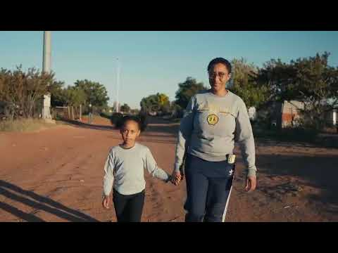▶Watch on YouTube
The story of Gina
Gina shares her journey from Oppermansdorp in the Free State.
Watch on YouTube ↗
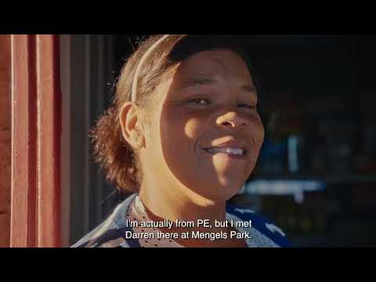▶Watch on YouTube
The story of Lizel Sol
Lizel Sol shares her journey from Oppermansdorp in the Free State.
Watch on YouTube ↗

Participant enterprise directory
View and fund participant-run MSME businesses
Discover enterprises established and grown through the GBL programme, and explore ways to support their next stage of growth.

This directory showcases participant-run micro and small enterprises that have emerged through a combination of coaching, skills development, business support and access to productive assets. Each profile highlights the entrepreneur’s journey, business activities and current growth opportunities.
Whether you're an individual supporter, corporate partner, funder, or customer, you can support participant-led enterprises and strengthen sustainable livelihoods in many ways. Where available, verified support and donation links are provided. Enquiries can also be routed through the programme team.

The Funders Wall recognises the organisations, institutions and individuals that have contributed to the growth of participant-run enterprises, making visible the partnerships and support that help businesses take their next steps.

Featured participant-run businesses
3 enterprise profiles currently listed

Bakery and catering
Hlengokuhle Cakes
Hlengiwe Makhanya · Madadeni, KwaZulu-Natal
With support to access baking equipment, business development training and coaching, Hlengiwe has expanded her bakery, increased production and built a growing customer base.

View business details
Enquire about supporting

Early childhood development
Nothile Early Learning Academy
Snothile Kubheka · Madadeni, KwaZulu-Natal
Business support and funding helped Snothile improve her facilities, accommodate more children, create employment opportunities and strengthen the centre's operations.

View business details
Enquire about supporting

Food services
Ntombenhle Fast Foods
Ntombenhle Ndlozi · KwaZulu-Natal
Training, coaching and productive equipment enabled Ntombenhle to grow from small-scale food sales into a catering enterprise serving larger events and community functions.

View business details
Enquire about supporting
Funders wall
Enterprise support partners
Recognising individuals, organisations and institutions that have contributed to the growth of participant-run enterprises.

- National Youth Development Agency (NYDA): Equipment and enterprise support for Hlengokuhle Cakes, Nothile Early Childhood Development and Ntombenhle’s fast food and catering business.
- Mukuru: Contributed a significant portion of the Thundafund crowdfunding target, which enabled support for an additional 15 participants also ready to grow their business.
- SACRAA: One of the first corporate backers of the Thundafund crowdfunding campaign.
- Thundafund individual backers: Francesco Di Salvo, Jaco Weideman and Justin Leach all supported the campaign to enable six entrepreneurs in urgent need of funding to get their business started.

About the programme
Evidence and resources
Learning from implementation

GBL is generating evidence about what works, where the barriers lie and what is required to strengthen the delivery of livelihood-focused social protection in South Africa.
Through implementation learning, Linkages Facilitator experience and research partnerships, the programme is informing approaches to participant support, institutional coordination and opportunities for wider adoption.
The public collection includes learning and policy briefs, research, project updates, media coverage, participant stories and video.

About the programme
Latest from GBL
Project developments, partnerships, learning and opportunities

Follow project developments, partner engagements, emerging lessons and new opportunities to strengthen livelihood pathways.
August 2026
Thundafund GBL crowdfunding: Inspired innovation paid off ↗
April 2026
Building livelihoods, sustaining hope ↗
March 2026
Ministerial engagement: Strengthening pathways from social protection to sustainable livelihoods ↗
November 2025
Celebrating progress and partnership under GBL ↗
29–30 October 2026
Upcoming update
DSD Roundtable
A featured project update will be added once the joint communications are approved, followed by the outcomes and commitments arising from the event.

About the programme
The team and contact
The people behind the programme, and how to reach us

Behind every participant’s journey is a dedicated team that connects people with the support and opportunities they need to build sustainable livelihoods.
From project coordination and implementation to on-the-ground coaching, the GBL team works closely with participants, communities and partners to turn livelihood plans into practical action. Linkages Facilitators provide personalised guidance, connect participants to opportunities and support their progress.
Together, the team brings the GBL approach to life, one participant and one opportunity at a time.

Core programme team
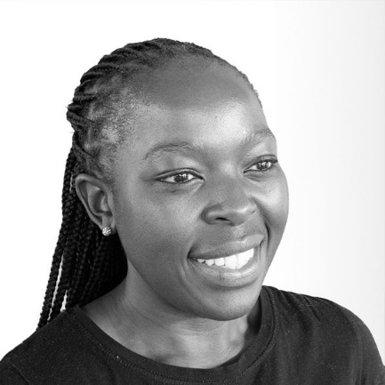
Phumelele Ngcobo
GBL Programme Lead
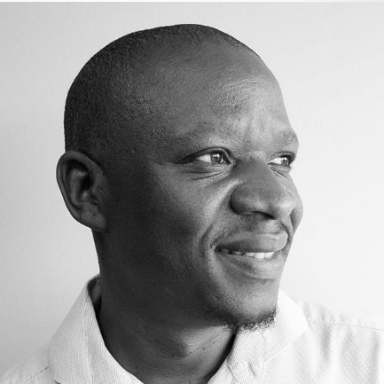
Lungisani Dladla
National Programme Manager Consultant
Matsiedi Malebatso
National Business Development Manager
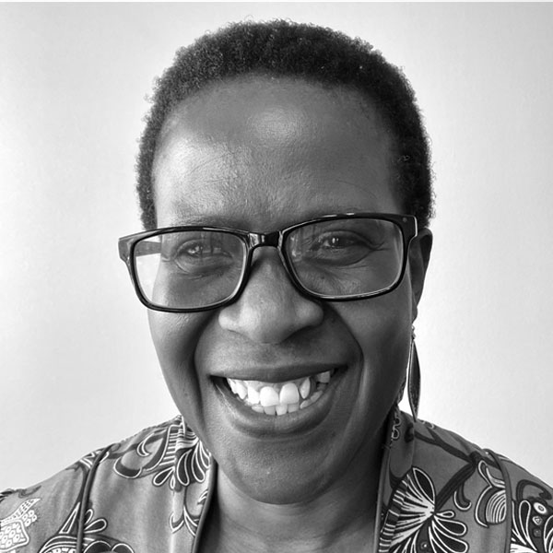
Vuyeya Segooa
Implementation Coordinator

FinMark Trust · Block B West, First Floor, Central Park, 400 16th Road, Randjespark, Midrand 1685, Johannesburg
Telephone +27 (0) 67 594 9291 · info@finmark.org.za

